1. **INTRODUCTION**
   1. overview

Development of an Apple smartphone began in 2004, when Apple started to gather a team of 1,000 employees led by hardware engineer [Tony Fadell](https://en.wikipedia.org/wiki/Tony_Fadell), software engineer [Scott Forstall](https://en.wikipedia.org/wiki/Scott_Forstall), and design officer [Jony Ive](https://en.wikipedia.org/wiki/Jony_Ive) to work on the highly confidential "Project Purple".

* 1. purpose

Apple has started assembling the [iPhone 14](https://www.theverge.com/23352282/iphone-14-review-apple) in India, according to [reports from TechCrunch](https://techcrunch.com/2022/09/25/apple-starts-manufacturing-iphone-14-in-india/) [and Bloomberg](https://www.bloomberg.com/news/articles/2022-09-26/apple-begins-making-iphone-14-in-india-three-weeks-after-launch?sref=ExbtjcSG). This marks the first time Apple has shifted production from China to India this quickly after the launch of a new iPhone.

1. **PROBLEM DEFINITION & DESIGN THINKING**
   1. Empathy Map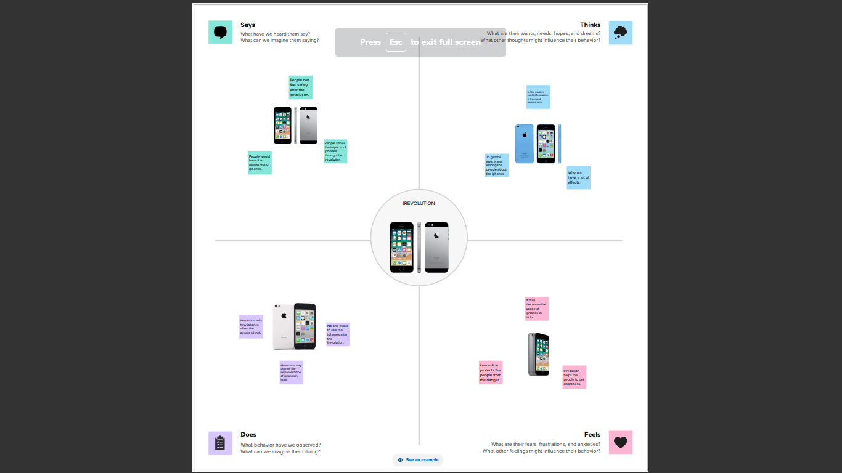
   2. **Ideation & Brainstoraming Map**

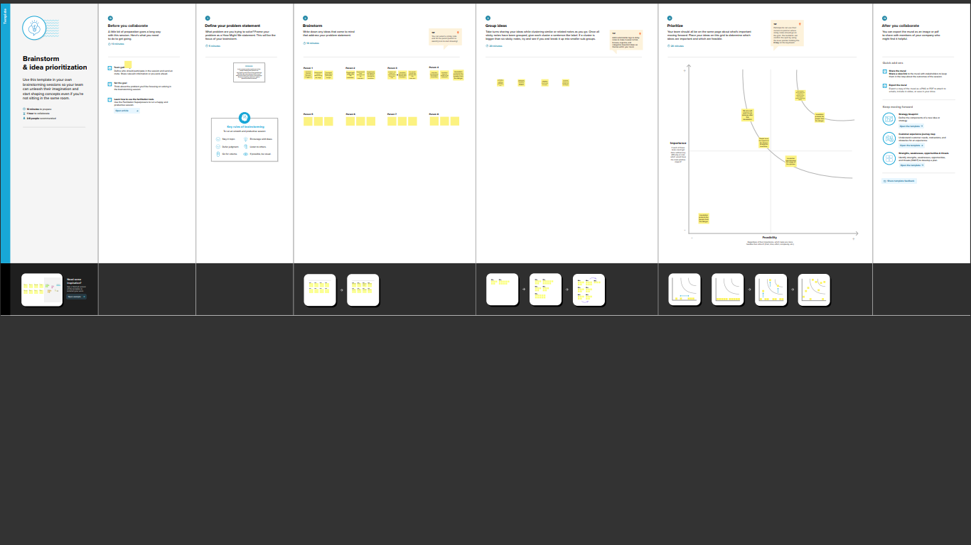

1. **RESULT**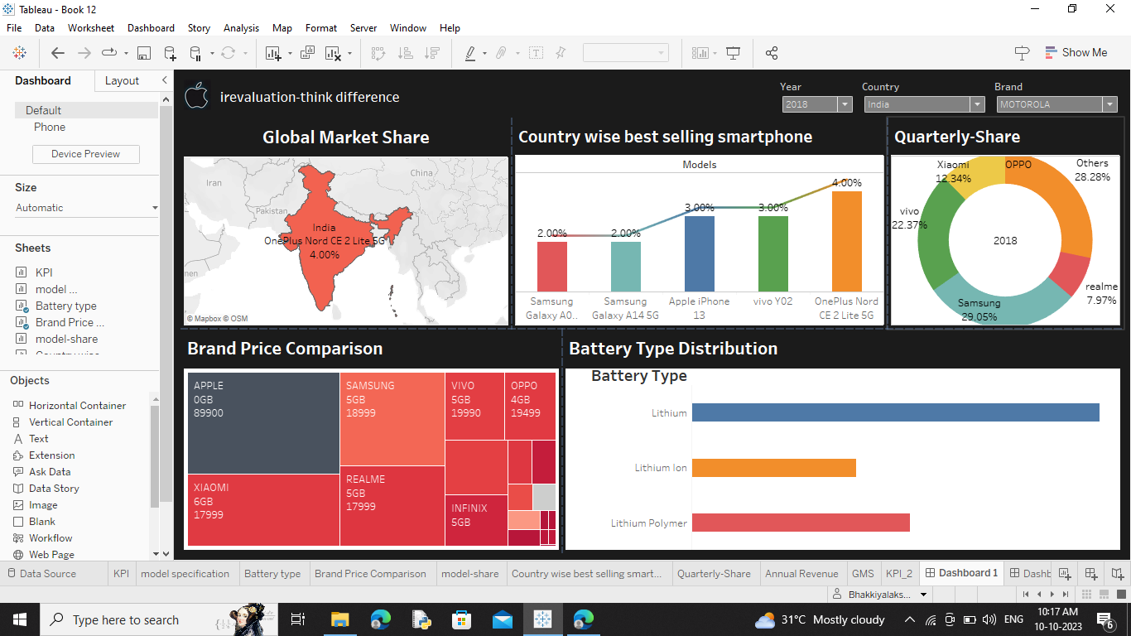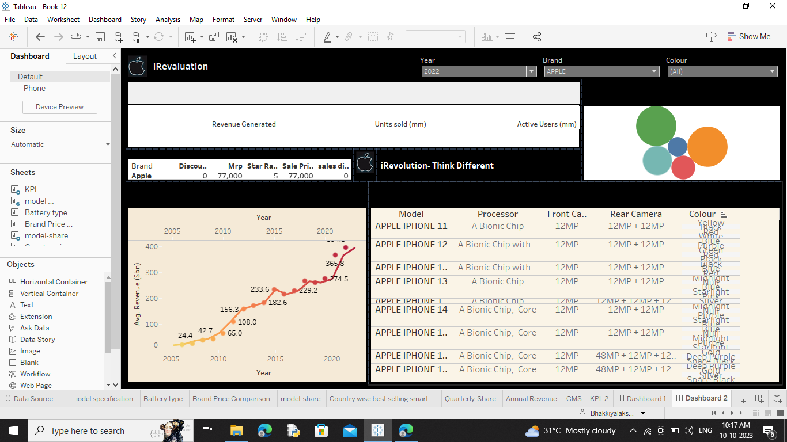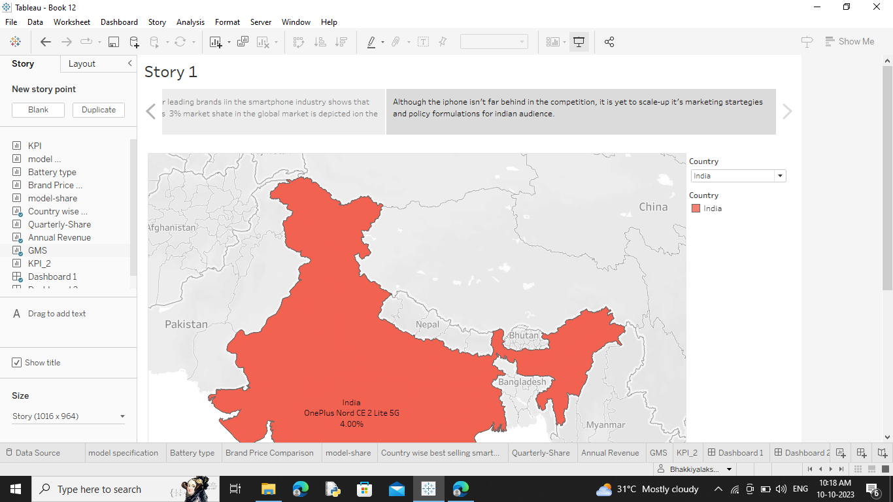
2. **ADVANTAGES & DISADVANTAGES**
   1. Advantages

Apple's decision to manufacture iPhones in India is a robust alignment with the Indian government's 'Make in India' initiative. By engaging local suppliers like Foxconn and Wistron, Apple is contributing to the nation's industrial growth, inculcating technological innovation, and creating thousands of jobs.

* 1. Disadvantages

The cost of owning an iphone is higher in India when compared to other countries. Connectivity: iPhone allows better connectivity to apple devices and it's very poor to Android and windows users which is the majority. Many features that iphone and apple provides cannot be used in India like apple pay.

**5. APPLICATIONS**

The iPhone has revolutionized the smartphones we see today with user-focused OS, powerful hardware, design architecture and much more. The smartphone industry has come a long way since the first smartphone was introduced in 1992

**6. CONCLUSION**

In summary, it is apparent that the iPhone was, and still, a remarkable invention of technological advancement. The iPhone provided a new way of mobile phone communication and usability. Its revolutionary technology has led to the variety of smartphones that are in use today.

**7.FUTUER SCOPE**

iOS development has a bright future, as iOS is the most preferred platform where most of the Internet of Things (IoT) get complete compatibility and support. Moreover, ultra modern home automation apps are getting developed using iOS only.12-Jun-2017. As a result, iOS App Development must keep track of these technological changes to provide a seamless experience for users. IoT, Machine Learning, Artificial Intelligence, and Augmented Reality are just a few of the latest technologies on which they can improve their knowledge.